Module-End -1
Module End Assignment
“Data Cleaning, Analysis & Visualization Excel”
Data Entry & Organization
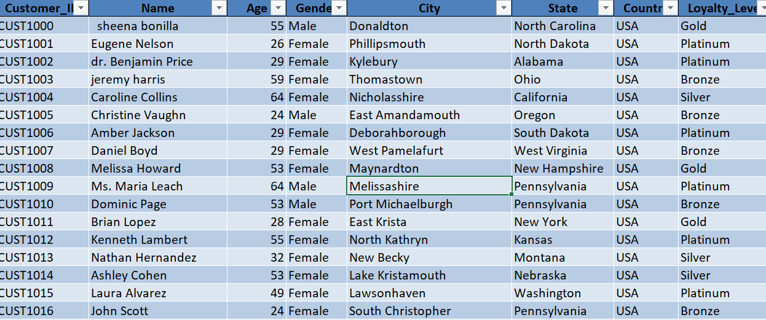

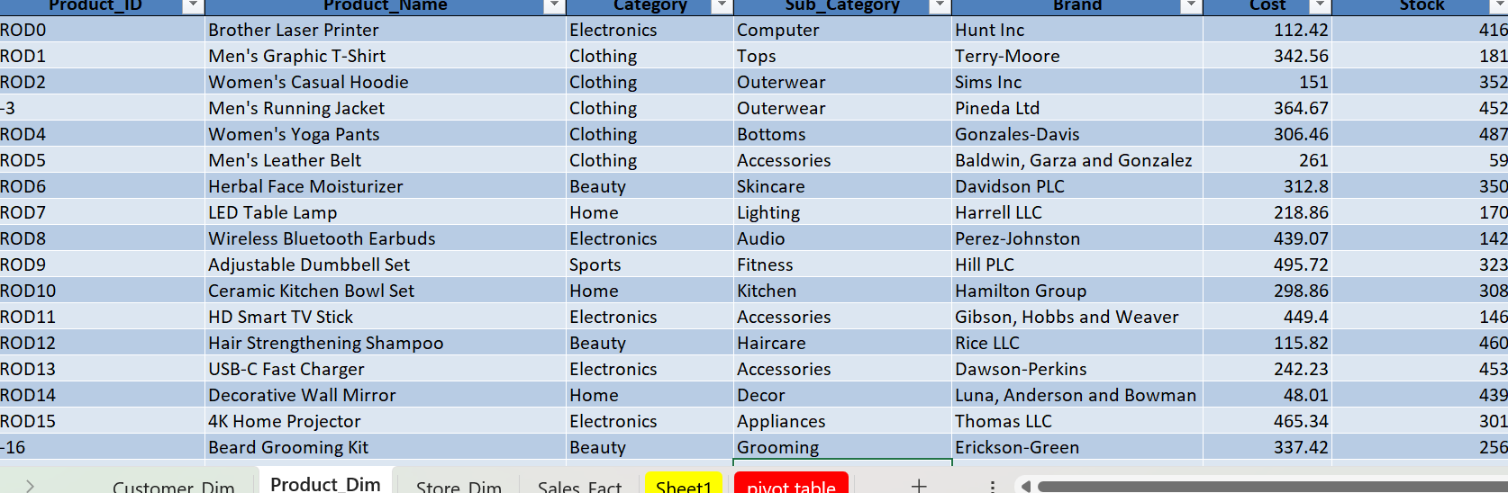

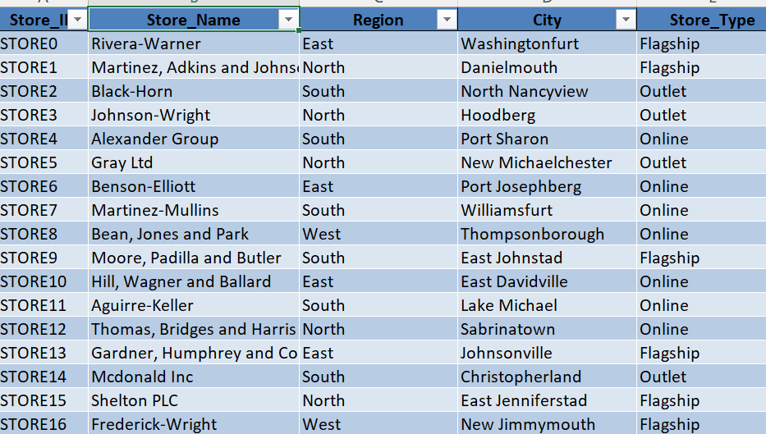
Data Cleaning & Transformation | Data Cleaning | Duplicates, Missing/Inconsistent Data;
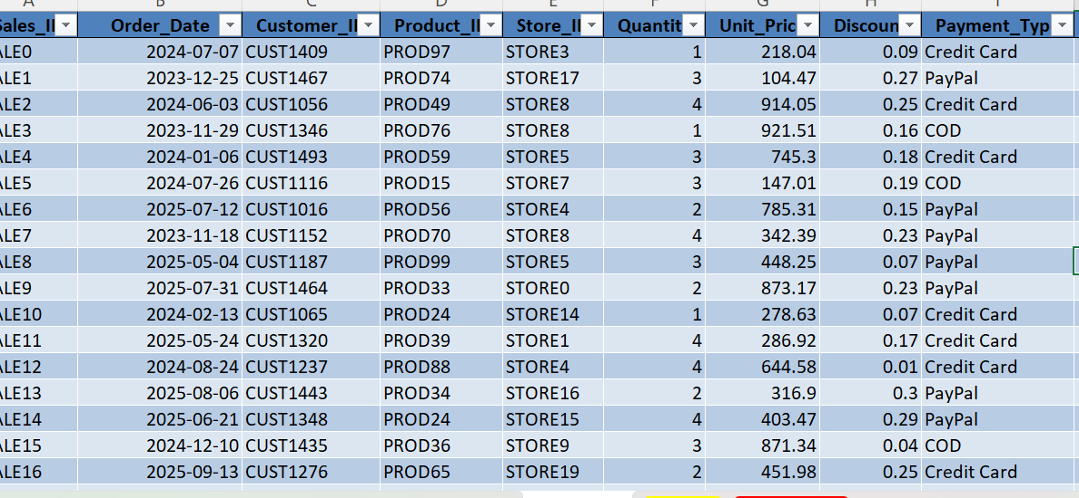

Spreadsheet Mgmt | Table Creation, Import
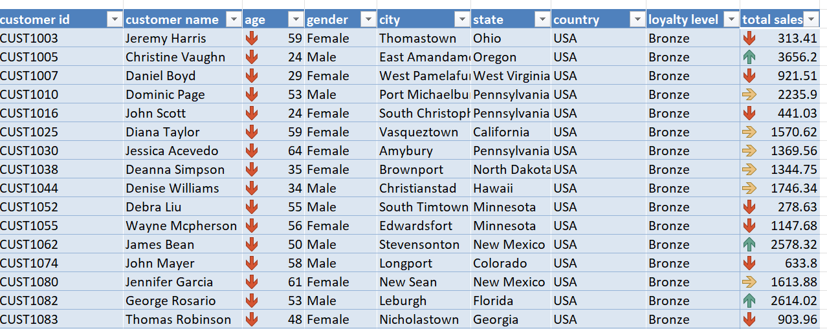

Excel Formulas & Functions

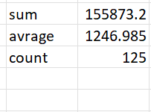
Data Summarization (Pivot)
Data Summarization

Pivot tables

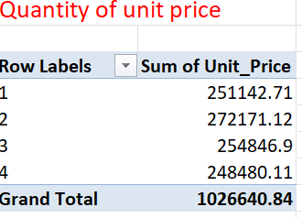

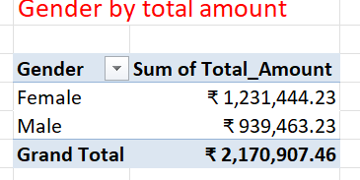
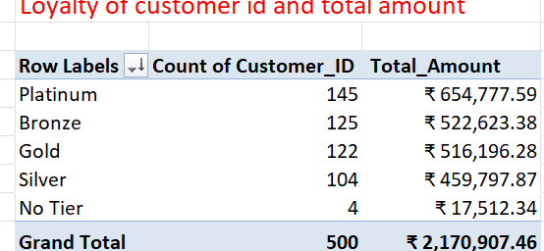

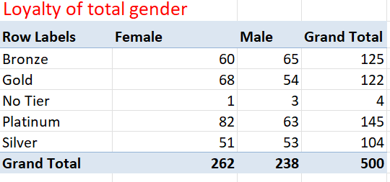
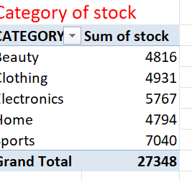

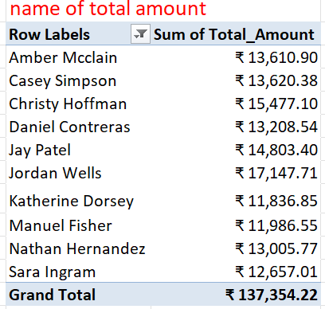
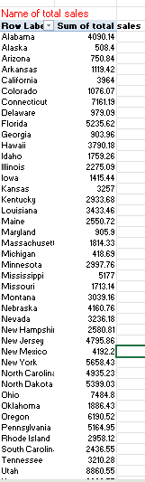

Data Visualization
DONUT CHART
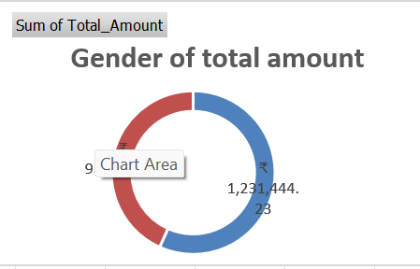
LINE CHART
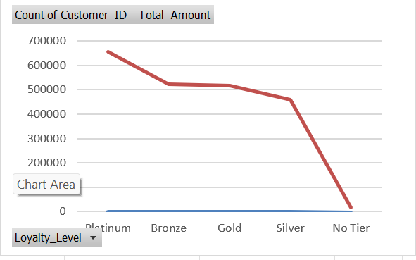
PIE CHART
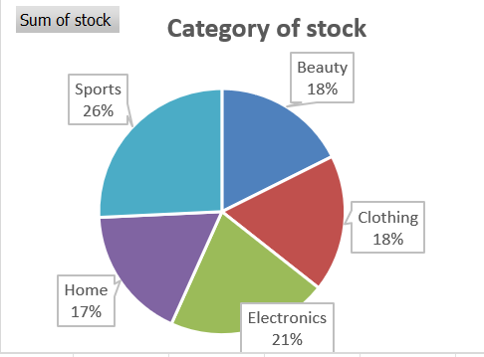
COLUMN CHART
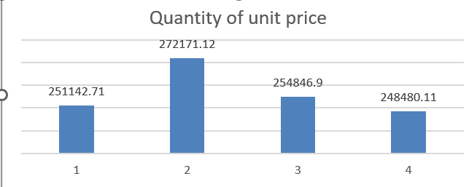
BAR CHART
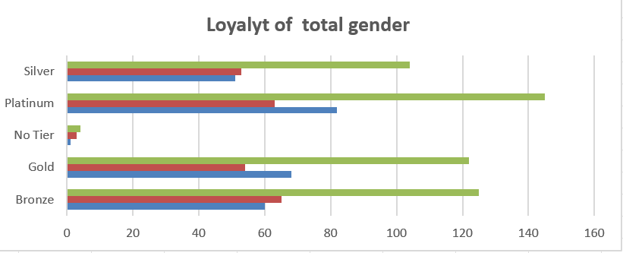

AREA CHART
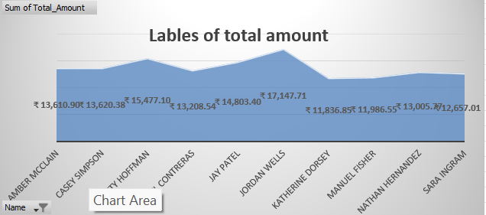
DASHBOARD

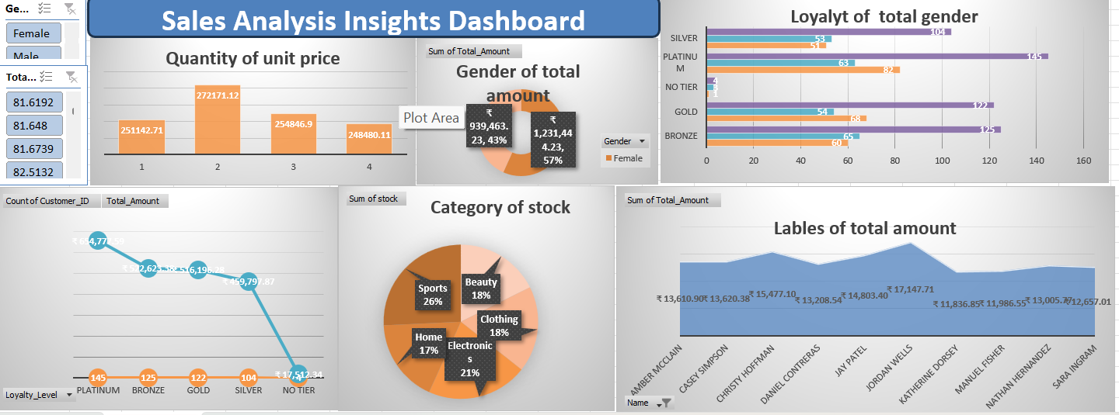

Project Summary

This project focuses on analyzing an E-commerce dataset using Microsoft Excel to understand sales performance, customer behavior, and product trends. The objective of the project was to perform data entry, cleaning, analysis, and visualization to transform raw data into meaningful business insights.
Initially, the dataset was imported into Excel and organized using structured tables. Data cleaning techniques were applied to improve data quality, including removing duplicate records, handling missing and inconsistent values, correcting formatting errors, and eliminating irrelevant columns. These steps ensured accuracy and reliability for further analysis.
Excel formulas and logical functions such as SUM, AVERAGE, IF, COUNTIF, VLOOKUP/XLOOKUP were used to perform calculations and categorize sales values into High and Low levels. Descriptive statistical measures including mean, median, mode, and standard deviation were calculated to understand overall sales distribution and performance trends.
Pivot Tables were created to summarize large datasets efficiently, enabling analysis of total sales by category, gender, loyalty level, and customer segments. These summaries helped identify patterns such as high-performing product categories and customer purchasing behavior.
Data visualization techniques were applied by creating multiple chart types including bar charts, pie charts, line charts, and dashboards. An interactive dashboard was developed to present key metrics such as total amount by gender, stock category distribution, loyalty analysis, and customer-level sales trends in a clear and visual format.
The analysis revealed important insights, including differences in purchasing patterns across customer groups, category-wise stock contribution, and overall sales performance trends. Visualization improved understanding and supported better decision-making.
In conclusion, the project demonstrates how Excel can be used as a powerful tool for end-to-end data analysis—from raw data preparation to interactive dashboard reporting—helping convert data into actionable business insights.

